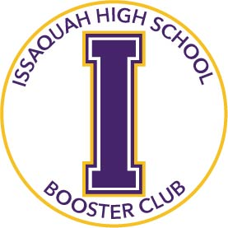
Issaquah High School Booster Club
Grant Request Form

The Booster Club will consider grant requests for any program, club, activity or sport that involves Issaquah High School students. The Booster Club is the second stop in the funds request process for all activities, clubs and sports, other than those not sanctioned by the Issaquah School District. All funding requests have to start with ASB, or if athletics, the Athletic Director. Please be sure to review the Funds Request Process. To initiate the process, and for questions contact the ASB Leader, Erin Connolly, connollye@issaquah.wednet.edu, or Athletic Direction, Luke Ande, andel@issaquah.wednet.edu.
Sport/Activity/Club: _________________________________________________ Date: ___________________________
Describe item to be funded and how it will be used, or attach details:
____________________________________________________________________________________________________________________________________________________________________________________________________
Life span of the item: __________________ Number of students impacted: _____________________________________
ASB Response to Request: Partial Funding Amount _________________________No Funding ______________________
If no or partial ASB funding, please explain reason(s) given: __________________________________________________________________________________________________
Total Cost, include tax/shipping(attach quote): _______________ Requested amount from Boosters: ________________
Grant Money sent to (Check one): Dedicated Booster Account: ____ Program’s ASB Account: ____ Supplier: ____
Supplier Name & Address: _____________________________________________________________________________
Supplier Contact Name and Telephone Number: ___________________________________________________________
Describe any fundraising activities to date: _______________________________________________________________
Other Considerations
- Is the team, club or activity is made entirely of full-time Issaquah High School Students. Yes / No
- Is there an Issaquah School District employee that leads the Activity, Sport or Club, even if not being paid by the Issaquah School District for such activity? Yes / No
- Is the funding requests and scholarship applications are endorsed by the lead Issaquah High School Coach or Advisor? Yes / No
- Number and percentage of families that currently support Issaquah High School Booster Club as a donor? (The donor list is found on the Booster website) Number: _______________ Percentage: ____________

Submissions

Name Advisor/Coach: ______________________________________ Email: ____________________________________
Advisory Committee Chair/Booster Member: _________________________ Email: _______________________________
Approvals

Booster Decision: ___________________________________________________________________________________
Funding Amount Approved: ______________________________________ Date: ________________________________
Booster Club President Signature & Date: ________________________________________________________________

